BUILDING A RAINBOW.

With the Covid-19 pandemic still casting a cloud of uncertainty over the running of the Australian National Show and Shine – Euroa on Sunday October 3rd, the committee continues to plan for the “best possible” scenario for the running of the event.
To date, the enthusiasm for the show from sponsors and exhibitors alike has been outstanding. With many potential attendees seeking information about the event, the growing list of interested motor clubs is already impressive.
Majestic Vanners, winners of the 2019 Best Club Exhibit award, will return with the aim of creating a “rainbow effect” by lining up twenty plus panel vans to replicate the colours of a rainbow! Spokesman Bret Kirwan said that they had performed this visual trick at a show in South Australia, with spectacular results for the crowd of spectators.
The Mercedes Benz Club of Victoria will display more than fifteen cars, including a 300SL “Gullwing”, an iconic car that we will tell you about in the near future.
Perennial favourites, Central Victorian Corvettes will once again occupy Area 1 along the pathway with a display of around fifteen cars, intent on taking the “Best Club Display” trophy back from the Vanners.
The Victorian Monaro and Jaguar clubs are also scheduled to attend, with Jaguar again supporting the Darryl Twitt Motors display of new Jaguar and other cars.
With the theme for this year’s event being the 1920s, we hope to display Judy McGrath’s 1927 Capitol Chev as a feature around centre stage, together with the possibilities of a 1920s Austin 7 powered race car and a Norton motorcycle – both still to be confirmed. 1920s vehicles are encouraged, and there will be prizes for the best 1920s costumes by both men and women.
Patrick O’Brien, winner of our 2019 event’s GMCU Best in Show, will return with his immaculate 350 Monaro with the ambition of taking out the Euroa Show and Shine’s first-ever “two-in-a-row”. There will be plenty of other entries who are equally determined that this will not happen!
Over in area five, the speedway stand will feature the Craig McDowell / Angie Luscombe FJ Holden restoration of local speedway legend Alan Luscombe. And talking about speedway legends, the ex-Barry Myers Camaro of Rick Pedler will return, together with Mr. Pedler’s Pontiac Firebird. We say “Legend” here, in recognition of Barry Myers’ recent induction to the Greater Shepparton Sports Hall of Fame Honour Roll. Mr. Myers is a regular attendee of the show, and we will no doubt see him again casting an expert eye over the exhibits at the speedway stand.
A firm decision on the running of the Euroa Show and Shine should be made around mid-August, and will depend of the approval of permits and the status of the Pandemic. In the meantime, the committee will keep prospective attendees advised on a regular basis.
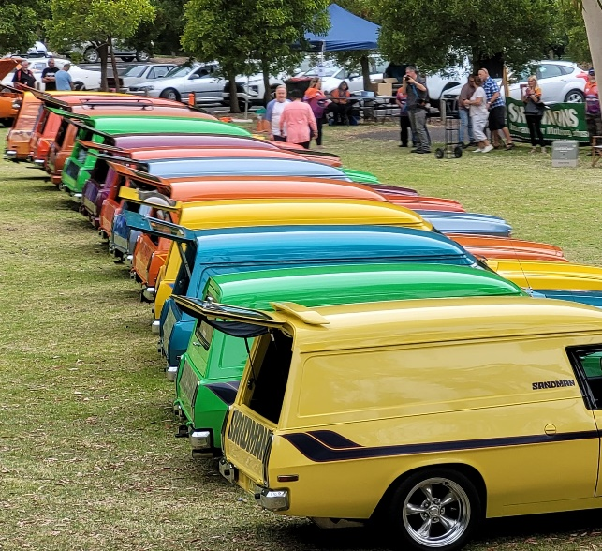
Show and Shine President Ross Holt emphasised that if the show does go ahead, it will be a ticketed event only with tickets available on line.
.. Ray Read
Picture: A “Rainbow” of the Majestic Vanners in South Australia. Picture by Bret Kirwan.

